Basket Strainer

Duplex Basket Strainers / Pipeline Strainers
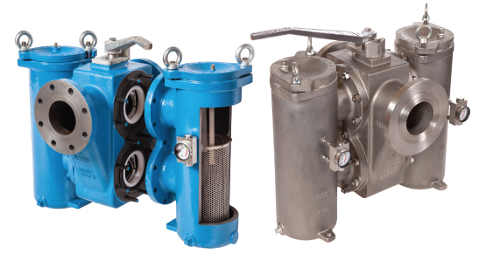

Application

Duplex Basket Strainers are designed for applications where continuous flow must be maintained whilst cleaning filter baskets. The strainer uses integral 3 way stainless steel ball valves with PTFE seals. This design provides drop tight shutoff eliminating costly and potentially dangerous leakage into the chamber not in use which can occur in some other duplex strainer designs. This also eliminates some problems which can occur in particular suction conditions where in other designs air ingress could occur. All parts of the valve mechanism are accessible after removing the basket chamber without taking the strainer out of the pipeline.
The handle covers the basket strainer chamber when in use and prevents accidental opening of the filter cover.
- Available in cast iron, bronze, carbon and stainless steel.
- Pipeline sizes from 20mm (3/4”) to 200mm (8”) (ask for details of sizes above 200mm).
- Available flanged in all common drillings including PN16 and ANSI150 (ANSI300 and 600 on request) and screwed ports both BSP and NPT or socket weld.
- XD range up to 13.8 Barg (pressure stated at 50C, lower pressure at higher temperatures, ask if unsure). Temperature limited by chosen seal. Pressure also limited by flange rating. 200mm and above lower working pressure.
- Large filter baskets areas, manufactured in st. steel 316.
- Various options including differential pressure indicator, magnets and
heating jackets.
- Can be coated internally and externally.
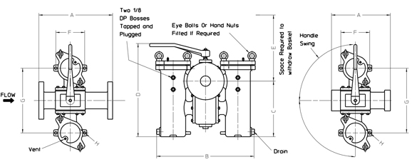

Bore Size | Flanged  Filters | Threaded  Filters | Common Dimensions (mm) |  |  |  |  |  |  | Basket  Area | MASS (dry)
 |  |  |  |  |  |  |  |  |  |  | Flanged | Screwed
 | A | A | B | C | D | E | F | G | H | CM sq | Kg | KG
DN20/25 | 178 | 142 | 329 | 148 | 305 | 243 | - | 224 | - | 130 | 21 | 19.8
DN32/40 | 238 | 191 | 284 | 205 | 377 | 335 | 136 | 260 | 12 | 243 | 33.5 | 31.7
DN50 | 270 | 254 | 468 | 271 | 471 | 400 | 158 | 310 | 14 | 425 | 55 | 54
DN65 | 343 | 292 | 560 | 347 | 579 | 538 | 158 | 310 | 14 | 701 | 107.5 | 103
DN80 | 343 | - | 560 | 347 | 579 | 538 | 196 | 370 | 14 | 701 | 108 | -
DN100 | 406 | - | 682 | 403 | 649 | 637 | 228 | 464 | 17 | 1057 | 169.5 | -
DN150 | 559 | - | 897 | 621 | 905 | 640 | 310 | 600 | 24 | 2060 | 390 | -
DN200 | 680 | - | 1368 | 772 | 1146 | 820 | 416 | 834 | 24 | 4022 | 763 | -
DN250 | 928 | - | 1520 | 731 | 1226 | 820 | 500 | 1000 | 22 | 5774 | 900 | -
N.B. Table data refers to PN16 & ANSI125/150 only

Basket Strainer and Mesh Data

Bag Filter, Bag Filters, Basket Strainer, Duplex Basket Strainers, Pipeline Strainers, Strainers
MESHES PER LINEAR INCH | SIZE OF APERTURE
20 mesh | 0.91mm
30 mesh | 0.56mm
40 mesh | 0.38mm
60 mesh | 0.25mm
80 mesh | 0.19mm
120 mesh | 0.13mm
200 mesh | 0.08mm
300 mesh | 0.05mm
The chart is for water (1cSt) flowing through a filter with an element coarser than 1 millimetre perforations. For correction factors for varying viscosity/mesh size, please see our Simplex data sheet or consult Oxford Filtration Ltd.

